# Visualization lies

Tasks:

1. You will locate and identify a visual that displays misleading information.
2. You will interpret the features of the visual in order to identify the mechanism(s) that is/are used by the "encoder" to mislead the "decoder."
3. For each mechanism that you identify, you will explain how it was used to mislead.

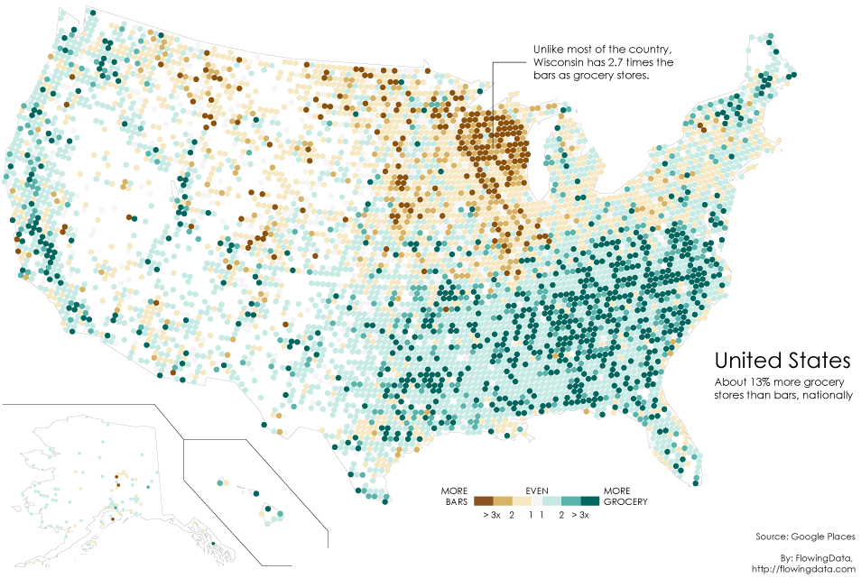

Source : Google Places

By: FlowingData,

[http://flowingdata.com](http://flowingdata.com/)

This chart shows the ratio of bars to grocery stores across the United States in 2008. The more bars, the darker the brown and the more grocery stores, the darker the green. Wisconsin's ratio is confusing because according to the statistics, there were plenty of places around the country that have more than three times as many bars but aren't as dark brown.

Misleading Components:

1. Hiding relevant data: the picture only shows the ratio inside a state, which can be a misinterpretation and makes people think it was the ratio against the whole country.